Contents

1. Introduction 2

2. Data Extraction 2

3. Data preparation 2

4. Data Analysis and Visualization 2

5. Appendix 5

6. Amendments 5

1. Introduction

In this project I am comparing the global average temperatures to the average temperatures of Cairo. In the coming sections, I will show the steps and tools used to extract, analyze and visualize the data.

1. Data Extraction

SQL query was used collect the raw data from the provided datasets and download it in CSV format for postprocessing. The following SQL syntax was used accordingly.

* The city list:

To view the available cities and select an appropriate one for analysis,

SELECT *

FROM city_list;

* The global average temperature for all years:

It is collected from the global_data table using this SQL Query:

SELECT *

FROM global_data;

* The average temperature for Cairo city for all years:

SELECT *

FROM city_data

WHERE city = ‘Cairo’;

* The other city’s temperatures for further analysis:

SELECT *

FROM city_data;

1. Data preparation

In data preparation Microsoft Excel was used to do the pre-analysis work like calculating the moving average and vlookup to join data from different tables.

A 10-years moving average was used to smooth the trend. Taking in to consideration that the data for Cairo is only available from year 1808. So, the values before 1808 in the global trend was ignored to have the same starting point.

Vlookup function was then used to join both the global and Cairo values in one table.

1. Data Analysis and Visualization

When analyzing the data, an outlier was observed in Cairo temperatures where on year 1818, the temperature suddenly dropped to 11.6 °C compared to 21.8 °C in 1817 and 20.31 °C in year 1819. It simply didn’t make sense for the temperature to drop by almost 10 degrees in a single year, so the outlier was replaced by the linear average of years 1817 and 1819.

This chart displays the 10-years moving average for the yearly temperatures of Cairo and global after correcting the mentioned outlier.

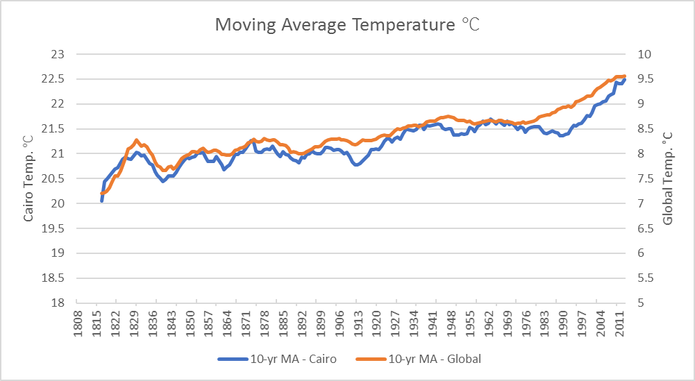

Chart : Cairo vs. Global Temperatures

From the chart we can notice the following:

* The temperature levels locally and globally have been continuously rising over the span of 203 years, with Cairo recorded and increase of 5.8 °C in 2011 compared to 1808, while the rise in global temperature was only 1.98 °C for the same span.
* From year 1817 to 1831 the moving average for both Cairo and Global had a relatively quick ramp rising by 1 °C for both trends in just 14 years.
* From year 1978 to 1993, the rise in Cairo temperature leveled off while the global temperature continued to increase steadily.
* Starting from year 1993, the temperature of Cairo started to increase drastically to pick up with the increase in the global temperature trend, which might indicate that at certain point soon
* There is a high correlation between the global and local temperature trends, where the correlation coefficient was calculated to be 75% based on the average temperature values.
* As there is a high correlation between both trends, we can use this coefficient to fairly estimate the temperatures in Cairo according to the global trend.

Looking at the temperatures of 3 other cities namely, Helsinki, Munich, and Wellington and adding them to the comparison, we can notice the following:

* As seen in chart 2, Cairo has the highest temperature levels followed by Wellington, and then Munich and Helsinki at almost equal levels.
* Both Wellington and Cairo have relatively high correlation in temperature trends of 0.49, while on the other side, there is a very weak correlation between Helsinki and Cairo.

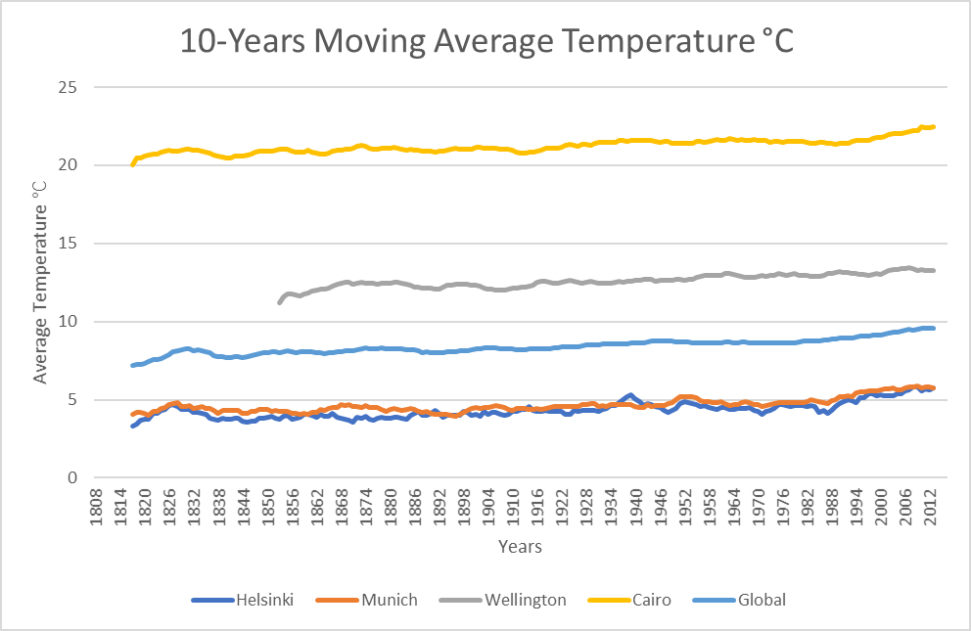

Chart : Temperature trends of multiple cities vs. global trend

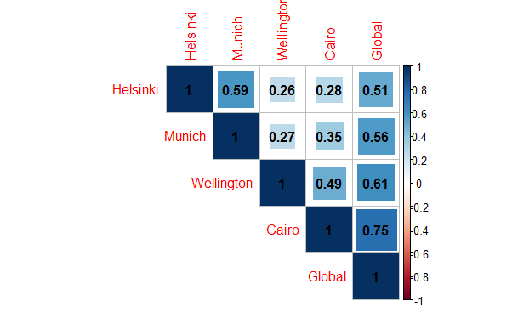

Chart : Correlation matrix for the temperatures of multiple cities

1. Appendix

The correlation matrix shown in chart 3 was plotted using the following R code:

> fav_cities = read.csv("C:/Users/monabil/Desktop/Explore weather trends/Fav_cities.csv")

> fav_cities =fav_cities[2:6]

> fav_cities[is.na(fav_cities)] <-0

> M<-cor(fav_cities)

> corrplot::corrplot(M,method = "square",type="upper",addCoef.col = "black")

1. Amendments

The moving average is calculated using the average function in excel as illustrated in the screenshot bellow and dragged down for the rest of the cells.

The 10 years window was chosen after iterating with 15-years as a first choice but it seemed to be too smooth. 5-years moving average was also checked out but the was volatile. So, I ended up selecting the 10-years window.

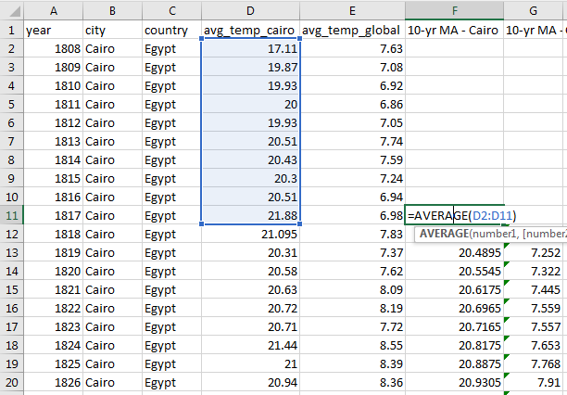

Figure - Moving average calculation method for Cairo.

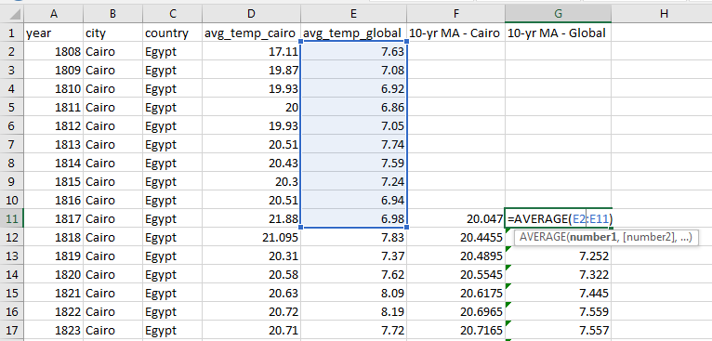

Figure - Moving average calculation method for global temperature.